Name: **Osama Mohamed Fattoh Abd Elgwad**

الاسم: **أسامة محمد فتوح عبد الجواد**

B.N: **165**

Date:

Topic: Operating systems

Github link:

Application Brief:

An Operating System Goal:

A Computer System's fundamental purpose is to execute user programs and facilitate tasks. Various application programs are used to perform this work, along with the hardware system. Operating System is a software that manages and controls the entire set of resources, and uses every part of a computer effectively. The figure demonstrates how OS serves as a conduit between the application programs and the hardware device.

Need of Operating System:

* **OS as a framework for computer programs:** the operating system offers a platform that can be used in addition to other applications called application programs. These application programs help the users easily perform a particular task. It acts as the user-to-computer interface. This is designed in such a way that the computer performs, monitors, and executes various applications.
* **Managing Input-Output unit:** Operating System also allows the computer to manage its own resources such as memory, monitor, keyboard, printer etc. Management of these resources is required for an effective utilization.The operating system controls the various system input-output resources and allocates them to the users or programs as per their requirement.
* **Consistent user interface:** Operating System provides the user an easy-to-work user interface, so the user doesn’t have to learn a different UI every time and can focus on the content and be productive as quickly as possible. Operating System provides templates, UI components to make the working of a computer, really easy for the user.
* **Multitasking:** The operating system manages memory and allows multiple programs to run in their own space and even communicate through shared memory with one another. Multitasking offers users a nice experience, since they can perform several tasks at one time on a computer.

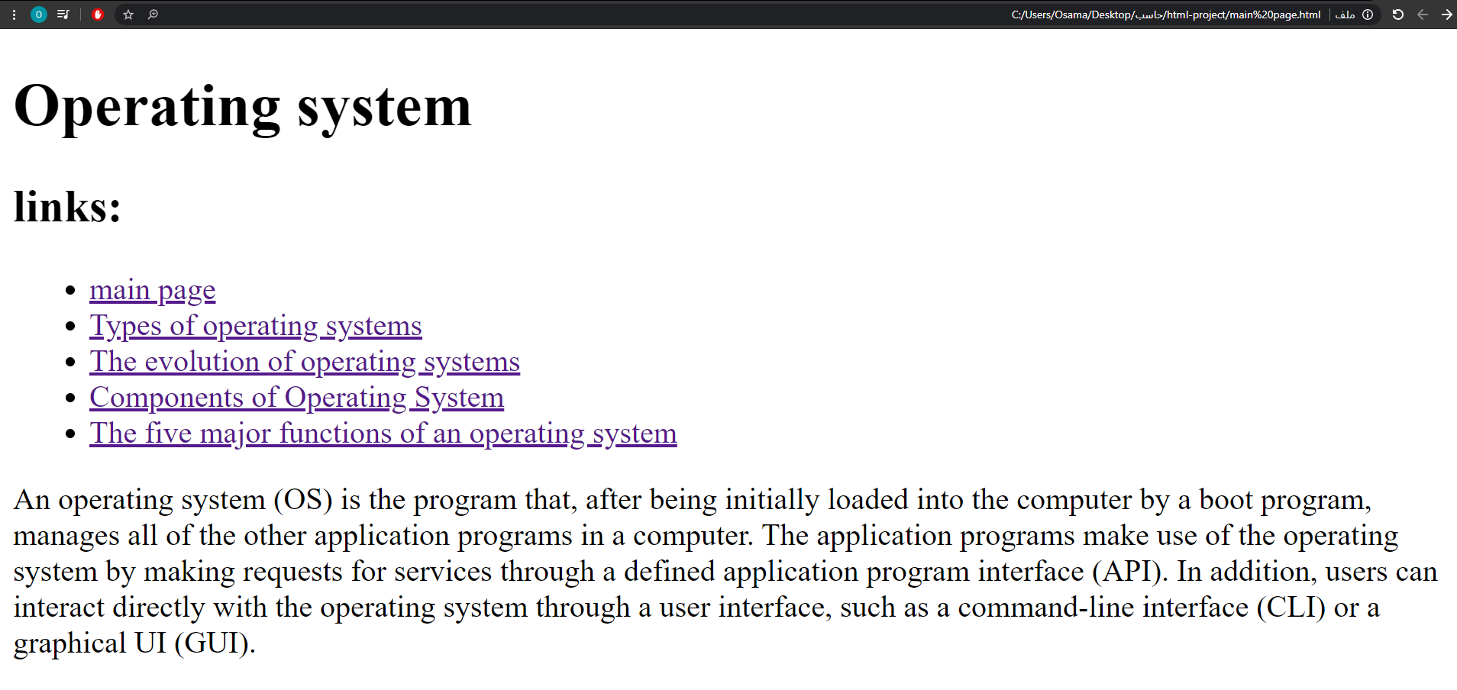Screenshots:

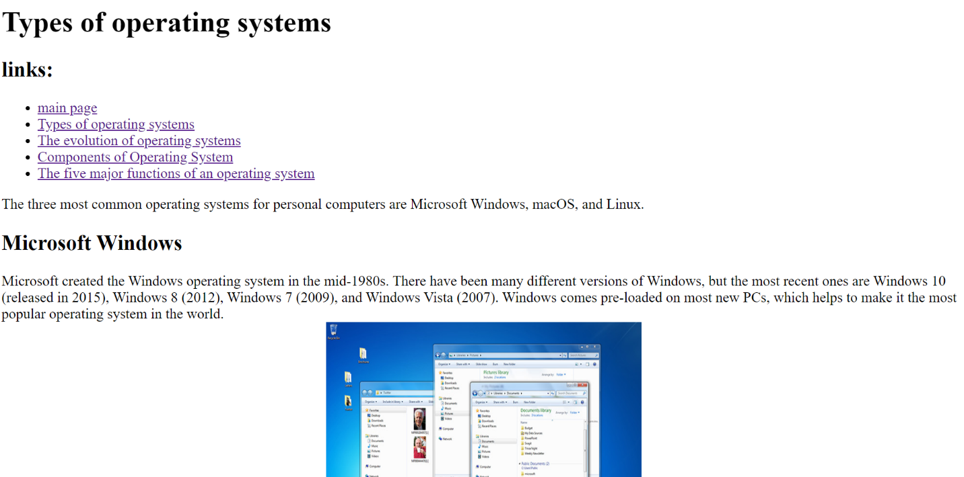

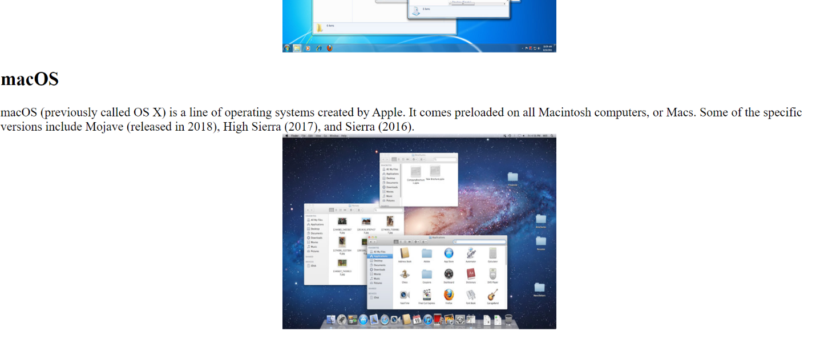

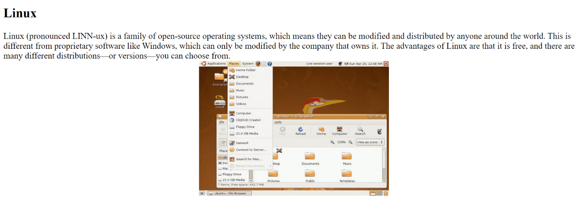

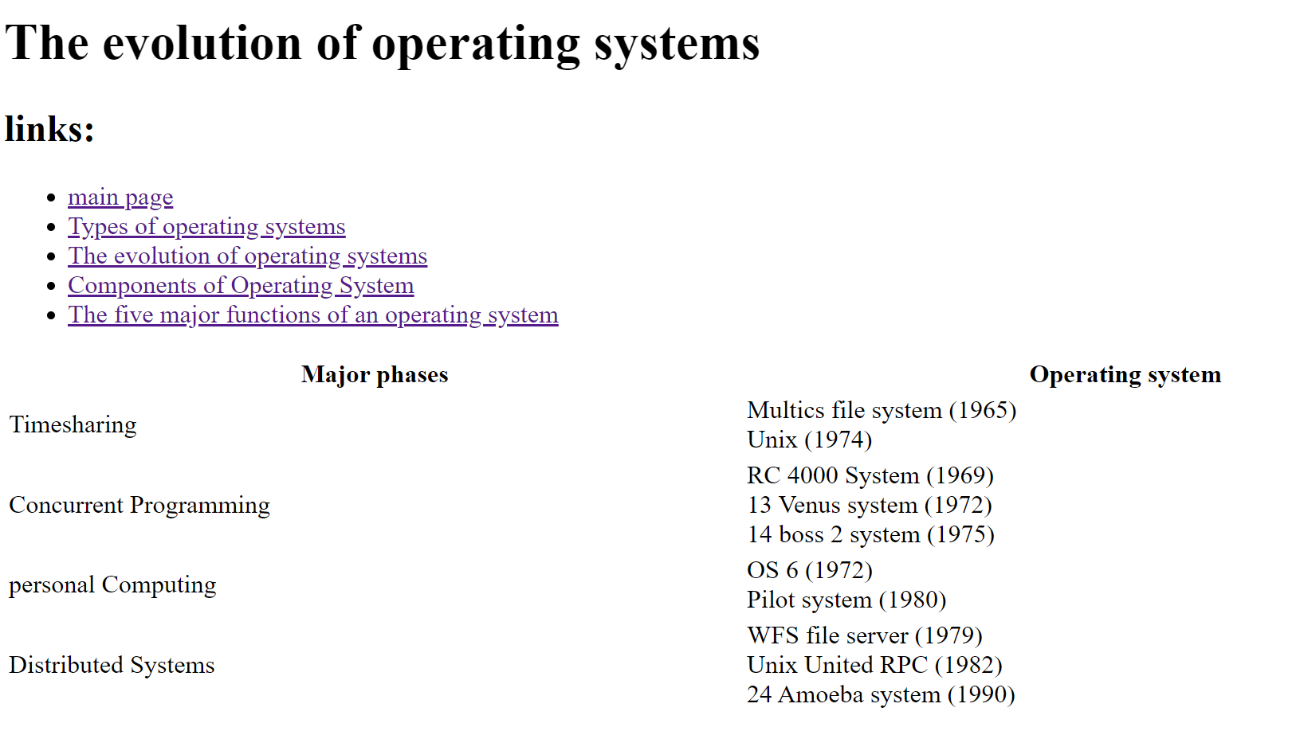

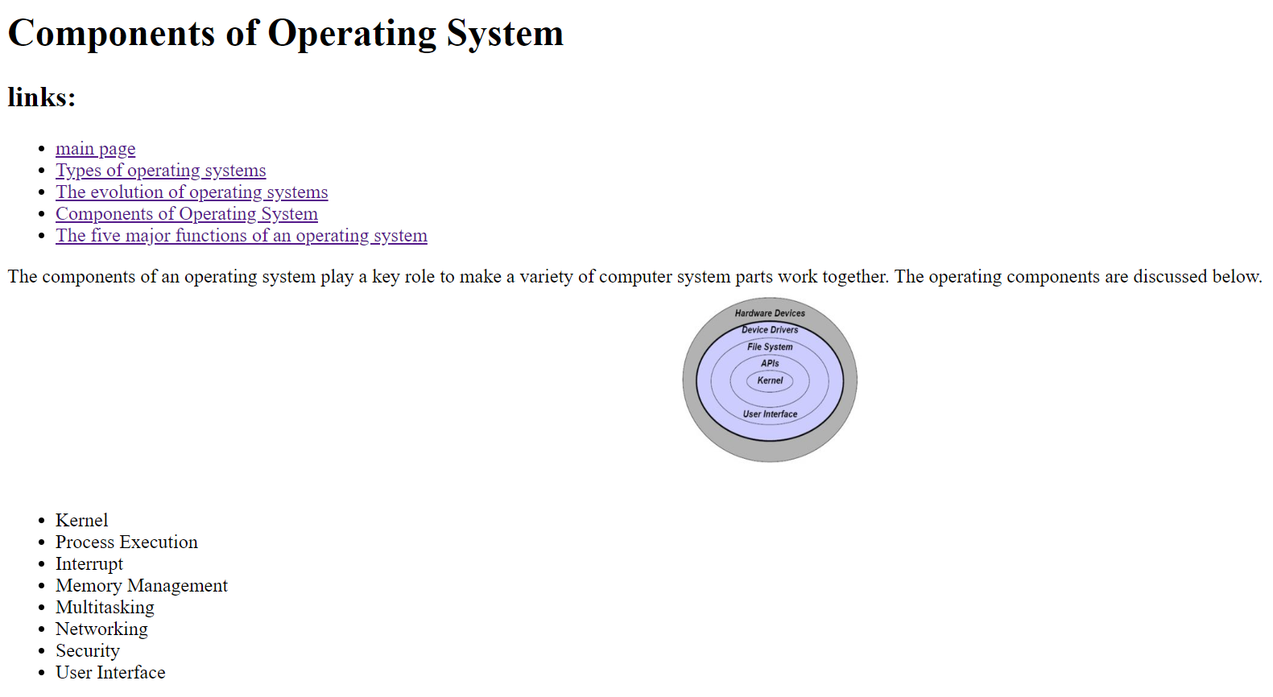

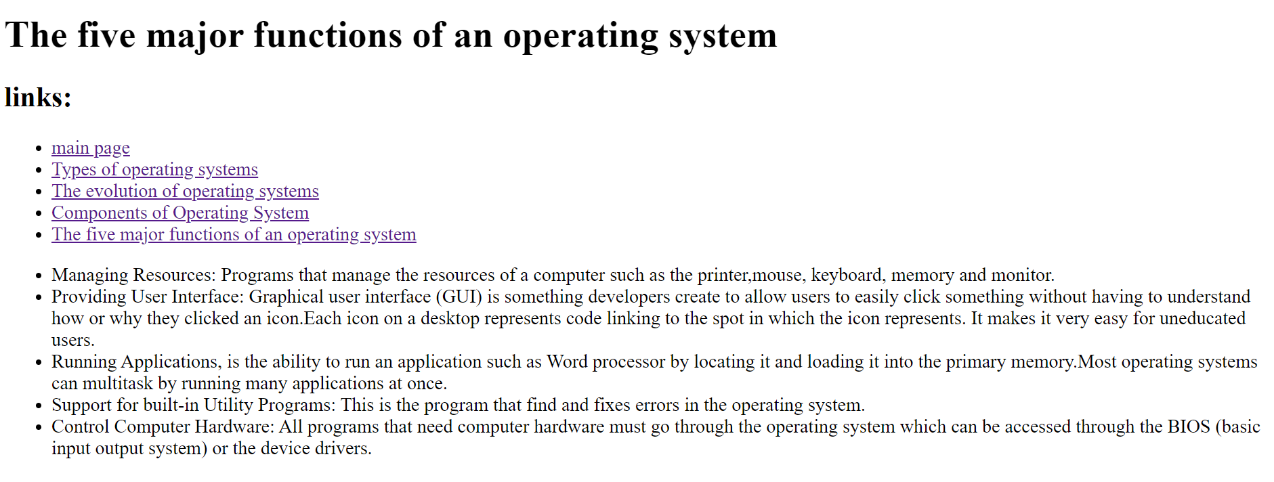

Source code:

